Task 1:
Entity-Relationship (ER) diagram is a visual representation of the entities in a database and the relationships between them. It is used to design and organize the structure of a database before implementation.
Example ER diagram: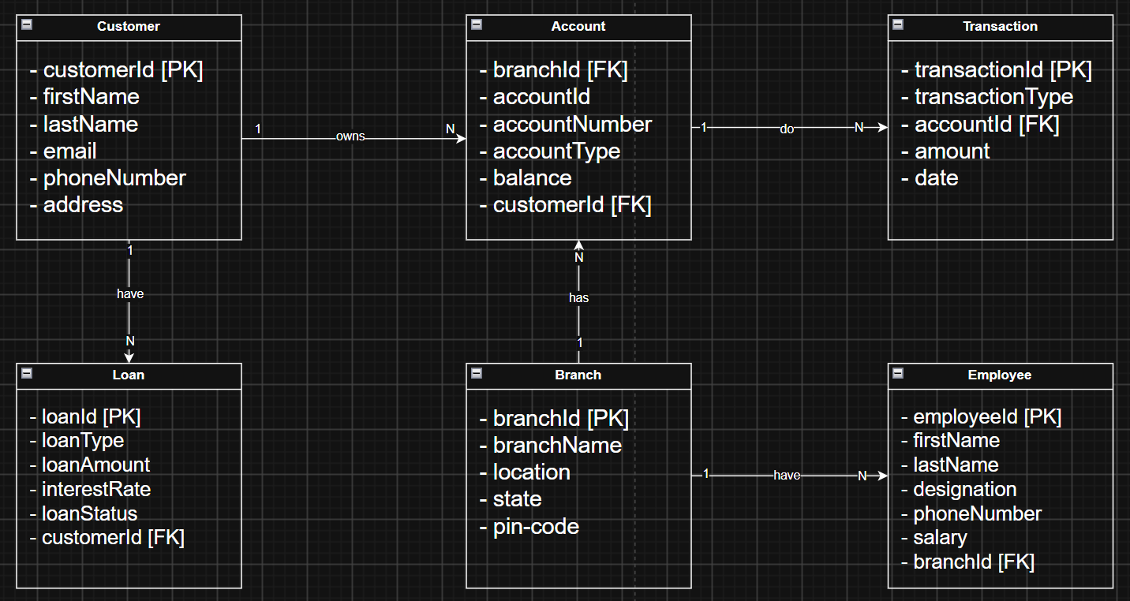

Task 2:
Indexing in RDBMS is a technique used to speed up data retrieval from a database table by creating a separate data structure on one or more columns. Indexing is done by creating an index on one or more columns of a table. The database stores the indexed column values in a separate sorted structure along with pointers to the corresponding rows. When a query searches for an indexed value, the database uses the index to locate the required rows quickly instead of scanning the entire table.

Task 3:
Indexing boosts performance on select query by not needing to search the entire database, hence improves the total performance.
But indexing slows down insert, update and delete operations since the indexing should also be updated while doing all these operations. It requires extra space for the storage of indexes also

Task 4:
ACID is a set of properties that ensures database transactions are processed reliably.
- Atomicity: A transaction is completed entirely or not at all. If any step fails, all changes are rolled back.
- Consistency: A transaction takes the database from one valid state to another, maintaining data integrity.
- Isolation: Multiple transactions can run at the same time without affecting each other.
- Durability: Once a transaction is committed, its changes are permanently saved, even if the system crashes.

PostgreSQL queries:
- Create database BankDB;
- select * from account;
- drop table account;
- Create table customer ( id int primary key, name varchar(25), email varchar(50), phno BIGINT, address varchar(100) );
- create table account ( customerId int, foreign key (customerId) references customer(id), accountId int primary key, accountNumber int, balance int );
- insert into customer ( id, name, email, phno, address ) values ( 1, 'adarsh', 'adarsh@123.com', 1234567890, 'xyz, abcd');
- insert into account ( customerId, accountId, accountNumber, balance ) values ( 1, 1000, 67892345, 1000);

- begin;
- insert into customer ( id, name, email, phno, address ) values ( 2, 'thor', 'thor@123.com', 1234567890, 'okk, abcd');
- insert into customer ( id, name, email, phno, address ) values ( 3, 'spiderman', 'spiderman@123.com', 1234456890, 'asda, abcd');
- insert into customer ( id, name, email, phno, address ) values ( 4, 'levi', 'levi@123.com', 1234512334, 'kds, abcd');
- commit;
- select * from customer;

- begin;
- delete from customer where id=3;
- rollback;
- alter table account add unique (accountNumber);
- alter table account alter column accountNumber type BIGINT;
- alter table account add constraint chk_balance check (balance >= 0);
- alter table account drop constraint chk_balance;
- alter table customer add column age int check(age>=18);

- update customer set age = 26 where id = 4;
- select * from customer order by name desc;
- select * from customer order by name;
- select * from customer order by name limit 2;

- select * from frontend_team, backend_team;
- update backend_team set project_id = 1010 where employee_name = 'Rohit';
- update frontend_team set project_id = 1200 where employee_name = 'Manoj';
- select * from frontend_team inner join backend_team on frontend_team.project_id = backend_team.project_id;
- select * from frontend_team left join backend_team on frontend_team.project_id = backend_team.project_id;
- select * from frontend_team right join backend_team on frontend_team.project_id = backend_team.project_id;
- truncate table backend_team;
- truncate table frontend_team;

- create index idx_frontend_team on frontend_team(employee_name);
- create unique index idx_unique_backend_team on backend_team(employee_id);
- create index idx_projects on frontend_team(project_id) where project_id > 1005;
- select employee_name from frontend_team where project_id = 1002;

- create schema test_schema;
- create table test_schema.student (id int, name varchar(50));
- drop schema test_schema cascade;

Home tasks:
Window functions - perform calculations across a set of rows related to the current row without grouping the result into a single row.

Window function keywords:
- OVER
- PARTITION BY
- ORDER BY
- ROWS
- RANGE

Type of window functions:
Ranking functions: ROW_NUMBER(), RANK(), DENSE_RANK(), NTILE()
Aggregate functions: SUM(), AVG(), COUNT(), MIN(), MAX()
Value functions: LAG(), LEAD(), FIRST_VALUE(), LAST_VALUE(), NTH_VALUE()

Rules while working on window functions:
- Always use the OVER() clause.
- PARTITION BY is optional and divides data into groups.
- ORDER BY is needed for ranking and running calculations.
- Window functions do not reduce the number of rows.
- They cannot be used directly in the WHERE clause.

JSON vs JSONB – both supported by PostgreSQL
JSON: Stores data as plain text. Preserves formatting and key order.
JSONB: Stores data in binary format. Faster for searching and indexing but does not preserve formatting or key order.

Full-text search - is a feature that allows efficient searching of words and phrases in large text data. It uses functions like to_tsvector() and to_tsquery() to find relevant text quickly.

